DECISION TREE

Decision tree learning is one of the predictive modelling approaches used in statistics, data mining and machine learning. It uses a decision tree to go from observations about an item to conclusions about the item’s target value.The item is represented in the branches while the target value is represented in the leaves. The goal of decision tree learning is to create a model that predicts the value of a target variable based on several input variables.

Decision tree learning is of two main types;

1. Classification tree which is when the predicted outcome is the class to which the data belongs.
2. Regression tree which is when the predicted outcome can be considered a real number e.g the price of a house.

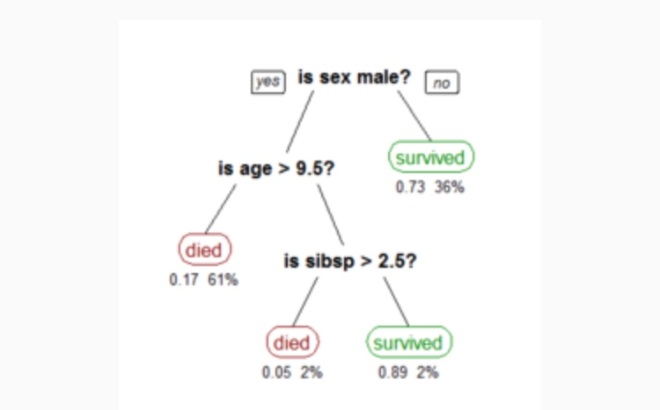

The sample diagram tree above illustrates the survival of passengers on the Titanic. The figures under the leaves show the probability of survival and the percentage of observations in the leaf. In general, the chances of survival of a passenger onboard the Titanic are good if the passenger is ;1. Female 2. A male younger than 9.5 years with less than 2.5 siblings.

In decision tree analysis, a decision tree can be used to visually and explicitly represent decisions and decision making.